**DBAS1007 – 2019-09-28 – Exercise: Creating the StoreCo ERD**

**Student: Ricardo Oliveira – W0428722**

1. For each table, identify the primary key and the foreign key(s). If a table does not have a foreign key, write None.

**A:** **EMPLOYEE**-P.KEY: EMP_CODE;F.KEY: STORE_CODE; **STORE**-P.KEY: STORE_CODE;F.KEY: EMP_CODE, REGION_CODE; **REGION**-P.KEY: REGION_CODE; F.KEY: None

2. Do the tables exhibit entity integrity? Answer yes or no, and then explain your answer.

**A:** Yes, all the tables have each primary key value unique and no null information

3. Do the tables exhibit referential integrity? Answer yes or no, and then explain your answer. Write NA (Not Applicable) if the table does not have a foreign key.

A: EMPLOYEE and STORE, yes, as each of the foreign keys points to an existing value in the referred table; REGION table is Not Applicable, as it does not have a foreign key

4. Describe the type(s) of relationship(s) between STORE and REGION.

A: It is M:1, as we can note that there are more than 1 store into the same region;

5. Create the ERD to show the relationship between STORE and REGION.

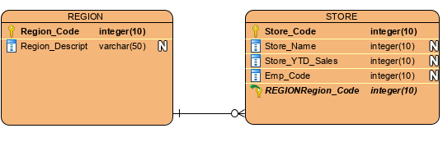

6. Create the relational diagram to show the relationship between STORE and REGION.



7. Describe the type(s) of relationship(s) between EMPLOYEE and STORE. (Hint: Each store employs many employees, one of whom manages the store.)

**A:** There are two relationships between EMPLOYEE and STORE, the first one is that the Store aways employs someone, as an 1:M relationship, as a stone can employ many employees; And the second one is about the Manager, so each STORE can employ one EMPLOYEE as a Manager, so 1:1 relationship.

8. Create the ERD to show the relationships among EMPLOYEE, STORE, and REGION.

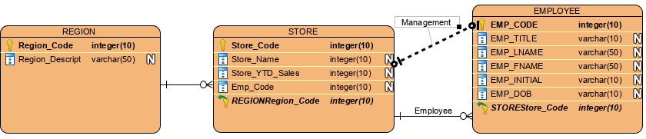

9. Create the relational diagram to show the relationships among EMPLOYEE, STORE, and REGION.

